Young Li

A13750891

Ying (Patrick) Pei

A13595990

Lab: (Monday 7-10PM A55)

Lab Room: WLH-2215

ECE 35 Lab 4 Report

**Introduction**

This lab is to specifically analyze capacitors and teach us how they work. The objective of this lab is to measure the time characteristics of RC circuits and demonstrate how RC circuits can affect the transmission of digital information.

**Procedure**

**Pre Lab part**

* First we are given a graph in the assignment sheet
* We are told to find the unknown capacitance value C in the given circuit and graph
* To do this we have to use Tau = RC as our formula and calculate the given stuff.
* Afterwards, we are told to design a procedure to find an unknown capacitance.
* We will be using this procedure for the first part of our lab.

**Lab**

* We are given an unknown capacitor and we are told to find the value of it.
* First we are to refer to our pre lab and use the procedure we came up with to find it.
* Afterwards we are told to build the circuit with the comparator in it.
* We follow the direction and guide to hook up the Op Amp and set up the circuit.
* Now we have to test if our comparator works properly.
* After setting up the circuit properly, we have to calculate the voltages for 75% 50% and 25%.
* With these, we have to change our Vin to these values to observe the changes in our oscilloscope.
* We are supposed to find the best one for our graph.
* We check these for 100Hz and 10kHz and gather six screenshots of our O-scope
* After this we obtain enough data for our analysis.

**Clean Up**

* Clean up and return everything back to our stations.

**Pictures and Diagrams**



**Figure 1 threshold value for 10kHz**



**Figure 2 threshold value for 10kHz**



**Figure 3 threshold value for 10kHz**



**Figure 4 threshold value for 100Hz**



**Figure 5 threshold value for 100Hz**



**Figure 6 threshold value for 100Hz**



**Figure 7 getting comparator to work**



**Figure8 Unknown capacitor value**

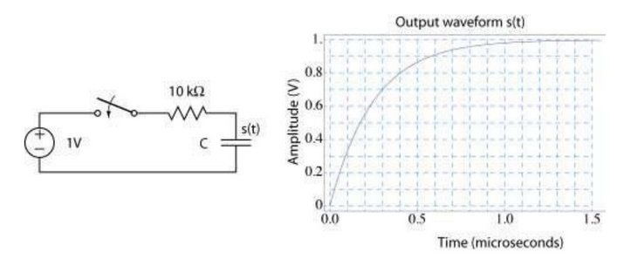

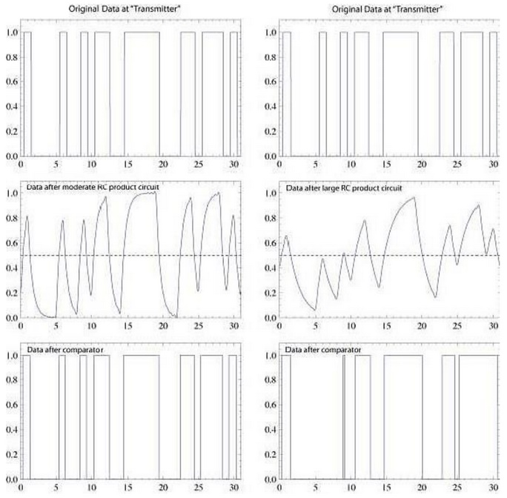

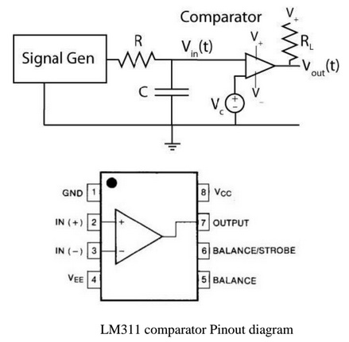

**Analysis and Tables**

During our experiment, we successfully derived the capacitor value by looking at the ratio of Vs and Vmax. The time constant which equates to resistance times capacitor and is also equal to Vs over Vmax. Since the ratio of Vs and Vmax is approximately 0.6321, we can easily derive the value of time from the graph and use that to calculate capacitor. During the lab 4, we used the OP-Amp in order to compare where it would determine whether the incoming value was high enough to warrant a high signal. Compared to the lab 3, it was used as a voltage or current controlled source. Moreover, during the comparator circuit building, the signal generator, set on square wave, will act as the digital data source. The RC circuit acts as a “low pass” filter and represents the effect of a communication “channel” which distorts the waveform. The Op-Amp comparator determines whether the incoming value was high enough to warrant a high signal. Because RC circuit distorts the waveform, frequency is proportional to the amount of distortion. Therefore, at higher frequency, it is much harder for the comparator to decode the signal. Each Vc value is shown in the print-outs at 25%, 50%, and 75%. From the printouts, we observe that the Vc value is proportional to the frequency of the waveform. (The higher Vc is, the more skinnier the reconstructed waveform is). This is because the threshold voltage at which the comparator considers as high input is much lower. The value of Vout is in agreement with our observation.Finally, in order to improve the RC circuit, such that a 10KHz signal will not be distorted, we could have increased the time constant of the circuit by increasing the resistance or the capacitance.

**Conclusion**

This lab was to specifically analyze capacitors and teach us how they work and we were able to collect enough data and analyze a capacitor. We were also able to find the capacitance of an unknown capacitor. The objective of this lab is to measure the time characteristics of RC circuits and demonstrate how RC circuits can affect the transmission of digital information. We were able to complete the objective and learn how capacitors work. In conclusion, this experiment can be considered a success because we were able to fully analyze and understand the properties of a capacitor.